**Instances at 6 Availability Zone**

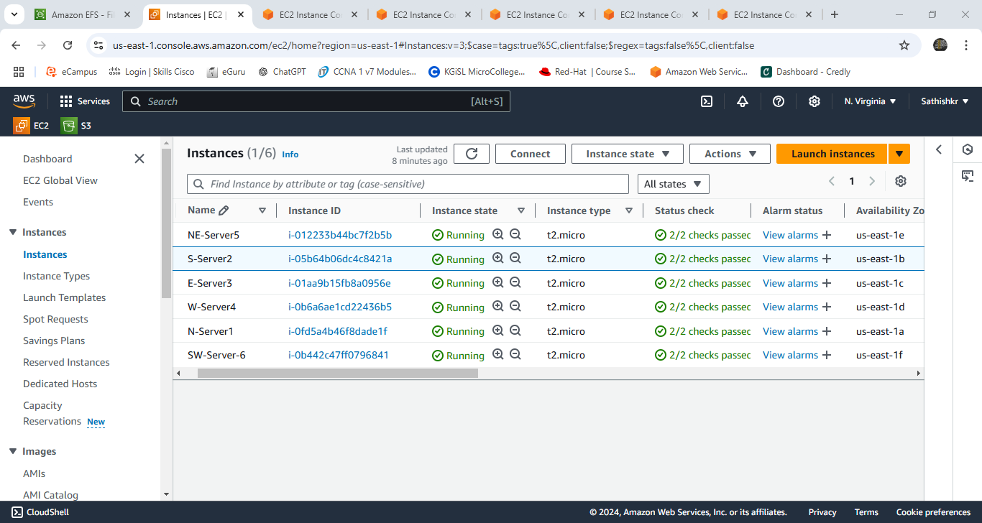

**File System Creation**

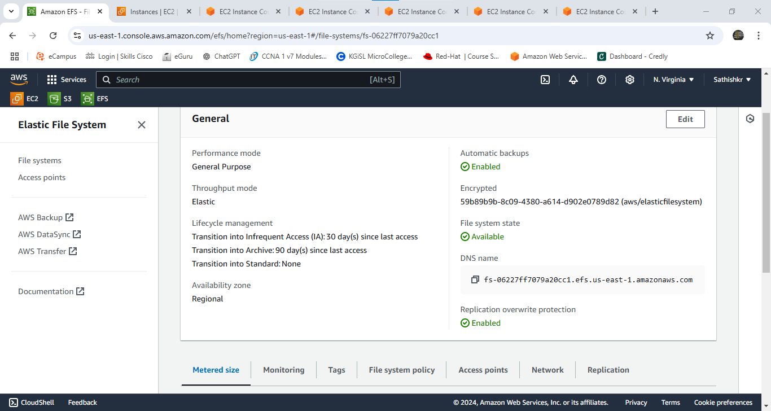

**Creating file that is accessible in various zone**

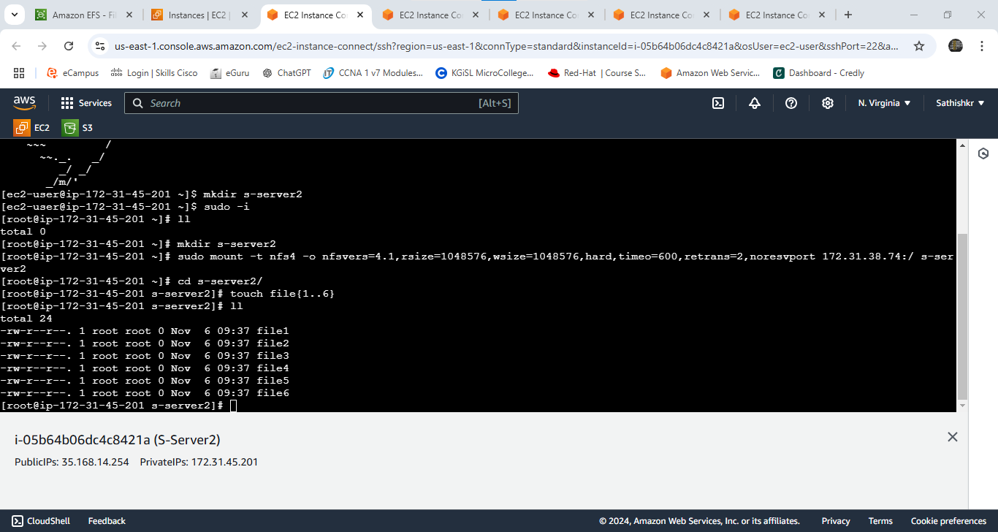

**Verifying file shared with other zones:**

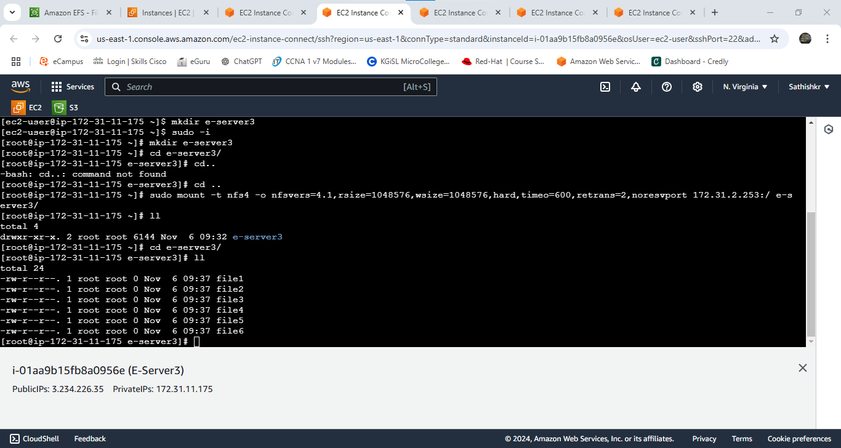

**Attaching file system - mount via IP**

